**Exercise No:** 10

**Register No:** 1518102067

**Date:** 20/11/2020

**Aim:** To write the python programprint the number of upper case letters and lower case letters in a given string.

**Program:**

def string_test(s):

d={"UPPER_CASE":0, "LOWER_CASE":0}

for c in s:

if c.isupper():

d["UPPER_CASE"]+=1

elif c.islower():

d["LOWER_CASE"]+=1

else:

pass

print ("Original String : ", s)

print ("No. of Upper case characters : ", d["UPPER_CASE"])

print ("No. of Lower case characters : ", d["LOWER_CASE"])

s=input()

string_test(s)

**Link:**

<http://103.53.53.18/mod/vpl/forms/submissionview.php?id=325&userid=1682>

**Output:**

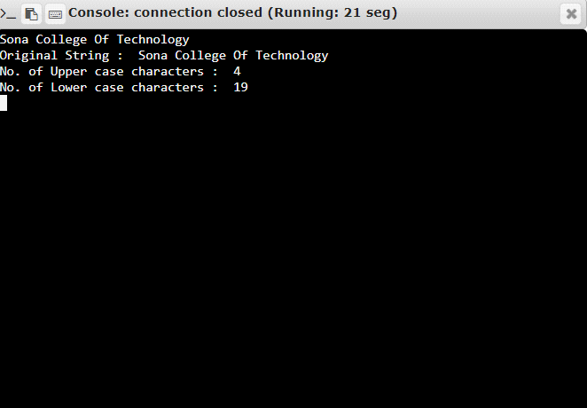

**Result:** Thus the program is executed successfully and the output is verified.